Lab Exercise 4- Working with Docker Networking

# Step 1: Understanding Docker Default Networks

Docker provides three default networks:

* bridge: The default network when a container starts.
* host: Bypasses Docker’s network isolation and attaches the container directly to the host network.
* none: No networking is available for the container.

# Inspect Default Networks

Check Docker's default networks using:

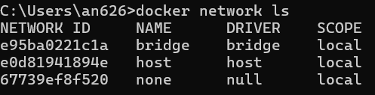

docker network ls

# Inspect the Bridge Network

docker network inspect bridge

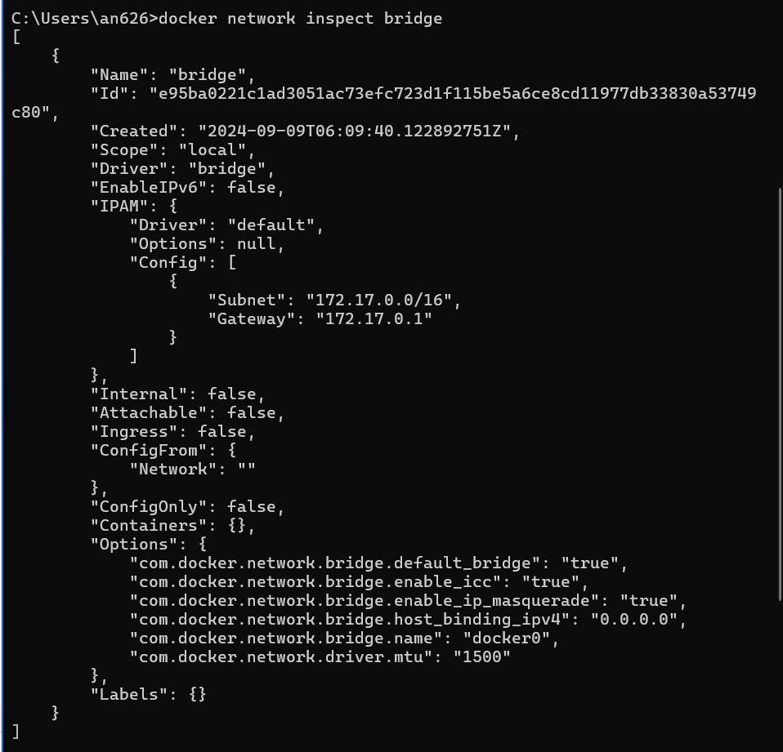

This command will show detailed information about the bridge network, including the connected containers and IP address ranges.

# Step 2: Create and Use a Bridge Network

* 1. **Create a User-Defined Bridge Network**

A user-defined bridge network allows containers to communicate by name instead of IP.

docker network create my_bridge



# Run Containers on the User-Defined Network

Start two containers on the newly created my_bridge network:

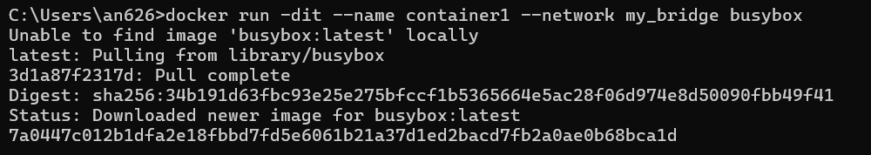

docker run -dit --name container1 --network my_bridge busybox

docker run -dit --name container2 --network my_bridge busybox

# Test Container Communication

Execute a ping command from container1 to container2 using container names:

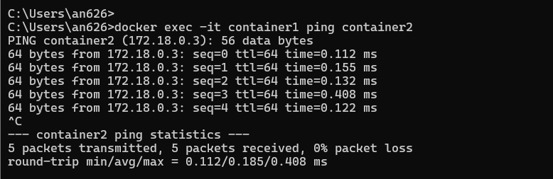

docker exec -it container1 ping container2

The containers should be able to communicate since they are on the same network.

# Step 3: Create and Use a Host Network

* 1. **Run a Container Using the Host Network**

The host network allows the container to use the host machine’s networking stack:



docker run -d --name host_network_container --network host nginx

Access the NGINX server via localhost:80 in your browser to verify the container is using the host network.

# Check Network

docker network inspect host

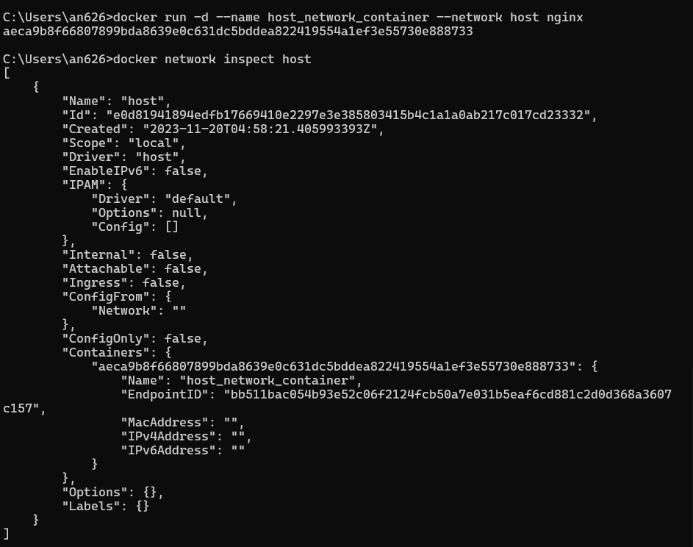

**Step 4: Disconnect and Remove Networks**

# Disconnect Containers from Networks

To disconnect container1 from my_bridge:



docker network disconnect my_bridge container1

# Remove Networks

To remove the user-defined network:



docker network rm my_bridge

# Step 5: Clean Up

Stop and remove all containers created during this exercise:

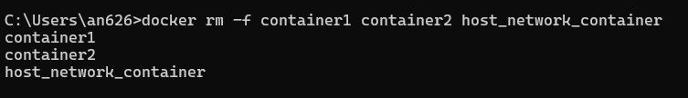

docker rm -f container1 container2 host_network_container